AMPLIFYING AFRICA'S MORAL VOICE IN THE GLOBAL PLASTICS TREATY POLICY BRIEF
Why Plastic Pollution Is Climate Justice Imperative
EXECUTIVE SUMMARY
Plastic pollution is not a waste management problem. Nearly all plastics are derived from fossil fuels, which makes the plastics economy inseparable from the climate crisis. Across Africa, plastic waste clogs drainage, intensifies flooding, contaminates farmland, and threatens fisheries and public health, while its production and disposal add directly to greenhouse gas emissions.
The Global Plastics Treaty, now negotiated under the Intergovernmental Negotiating Committee, must move beyond downstream waste fixes to confront production, financing and equity across the full plastics lifecycle. Faith communities, among the most trusted institutions on the continent, are positioned to anchor treaty accountability and public ownership, provided they are treated as negotiating partners rather than excluded observers.

1. PLASTICS Are a Climate Justice Crisis
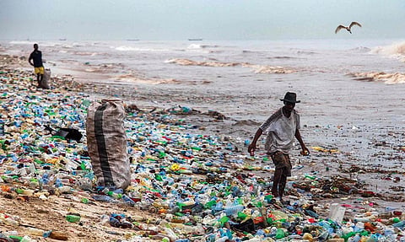
Public discourse often portrays plastic pollution as a problem of littered streets, clogged waterways and polluted beaches. These are visible symptoms, not the source. The crisis begins with the extraction of oil, continues through manufacturing and transport, and extends through disposal and leakage into ecosystems, long before a bottle ever reaches a river.
These leakages reach the food people eat and the water they drink. Agricultural plastics, mulch films, greenhouse sheeting, packaging, degrade into fragments that accumulate in soils, altering fertility and entering crops grown for local consumption and export.

IN THE WORLD'S OCEANS
82–358 trillion plastic particles
An estimated 1.1 to 4.9 million tonnes now circulate in the oceans, ingested by fish and shellfish and detected in tap water, bottled water, and human blood and tissue.

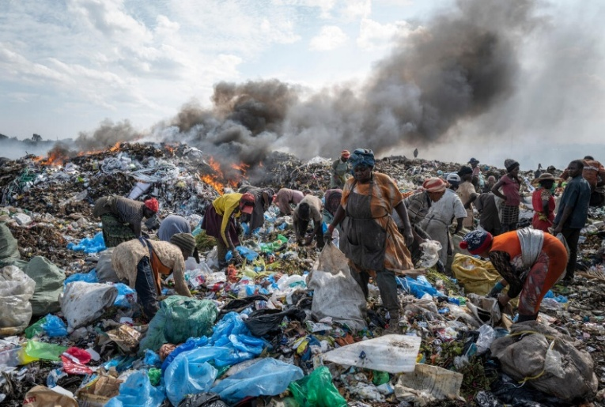
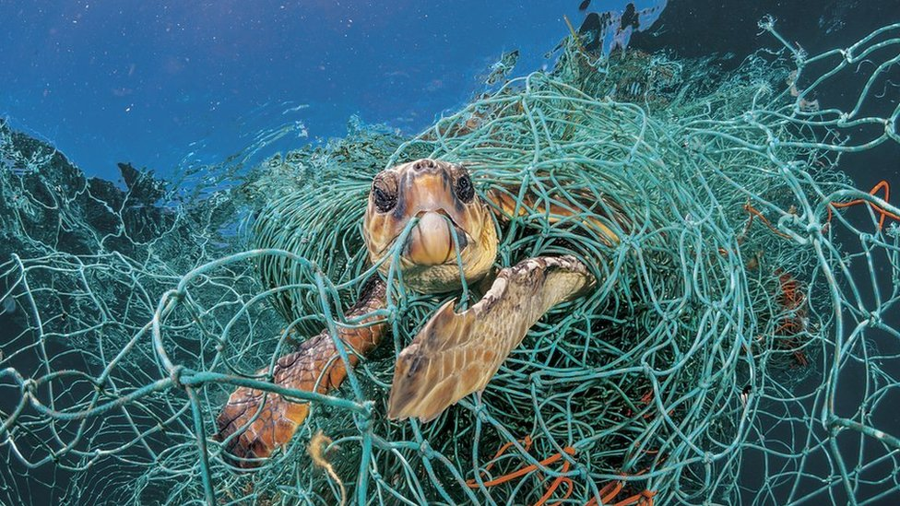

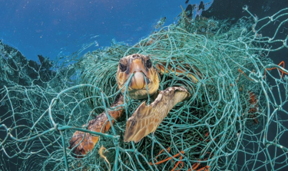
For African communities that depend directly on rivers, lakes and coastal fisheries for food and livelihoods, this convergence of ocean pollution, contaminated food systems and compromised drinking water is a direct and escalating threat.
Nearly 98 percent of single-use plastics are produced from fossil fuel feedstocks. As global demand for fossil fuels in energy softens, plastic production is projected to become an increasingly important outlet for oil and gas industries, an outcome that, left unchecked, locks in future emissions growth and undermines global climate goals.
Many African countries already face mounting climate pressure: floods, droughts, ecosystem degradation. Mismanaged plastic waste compounds this by blocking drainage and waterways, acting as a threat multiplier in communities already exposed to climate risk. The economic costs, damaged infrastructure, reduced agricultural productivity, declining fisheries, rising waste management and health expenditure, fall disproportionately on the communities least able to absorb them.

2. Why the Treaty Matters for Africa
The Global Plastics Treaty is the most significant international environmental negotiation since the Paris Agreement. Unlike earlier efforts focused on waste management, it seeks to address plastic pollution across its full lifecycle: extraction, production, consumption, design and disposal.
For Africa, the treaty carries both opportunity and risk. A strong agreement can support circular economy investment, stronger waste systems, technology transfer and implementation financing. Weak provisions on production, financing and accountability would leave developing countries with greater responsibility and insufficient means to meet it, particularly where obligations fail to reflect differing national circumstances.
Negotiations remain divided over whether the treaty should govern the full lifecycle of plastics or focus narrowly on waste. For Africa, this is ultimately a question of who bears responsibility for a crisis generated largely outside the continent but experienced acutely within it. The table below summarises where the ambition gap is widest.

ISSUE | HIGH-AMBITION PROPOSAL | LOW-AMBITION PROPOSAL
Production caps | A legally binding global cap on virgin plastic production, cutting new plastic entering the market. | Oil, gas and petrochemical producers oppose caps and favour downstream fixes: recycling, product design, better waste management.
Hazardous chemicals and single-use plastics | A binding global list banning specific single-use products and hazardous additives. | National flexibility, with each government deciding which products or chemicals to restrict.
Financing mechanism | A dedicated global fund, financed by wealthier nations and producers, for mandatory implementation support. | Reliance on existing environmental funding mechanisms, avoiding new financial commitments.

3. Plastics and Industrialization
Discussions on plastics cannot be separated from Africa's aspirations for industrialization and economic transformation. Many African countries hold substantial oil and gas reserves and, after decades of energy poverty, reasonably see their exploitation as a route to growth, jobs and energy access. As global energy demand for fossil fuels softens, plastics production is increasingly positioned as the next growth market for those same reserves.
That aspiration is legitimate. But pursuing plastics-linked industrialization as a primary growth strategy risks trading short-term gain for long-term environmental, health and financial liability. New petrochemical infrastructure entrenches dependency on volatile fossil fuel markets, creates stranded-asset risk as regulation tightens, and transfers pollution, climate and clean-up costs onto a generation that had no part in the decision.
In this sense, plastics-driven industrialization functions as a form of intergenerational debt. The benefits are captured now. The costs, degraded ecosystems, contaminated food and water systems, constrained development options, are inherited later. A robust treaty, paired with deliberate investment in circular value chains and green manufacturing, could let Africa industrialise without locking future growth into the same fossil-dependent, linear model wealthier economies are now struggling to unwind.

4. Faith Communities as Strategic Partners
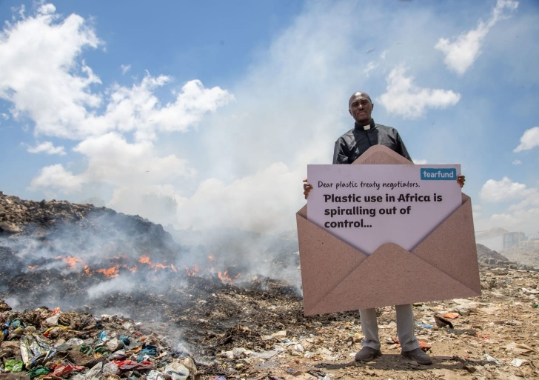
One notable gap in global environmental negotiations is the limited visibility of faith communities, despite their extensive societal reach. Across Africa, religious institutions shape public values, social norms and behaviour at a scale unmatched by most civil society actors. Pollution is usually discussed in technical terms: infrastructure, regulation, innovation, financing. These dimensions are essential, but they cannot deliver the behavioural and societal transformation the crisis demands at scale.
A dialogue with faith leaders during World Environment Day 2026 stressed that Africa's engagement must be guided by environmental justice, equity and shared but differentiated responsibility, including protection for vulnerable communities and recognition of the informal waste workers who carry the system.
Faith communities remain among the most trusted and influential social actors on the continent. Their reach extends into communities often beyond formal environmental programmes, positioning them to influence behaviour and mobilise collective action, while bringing an ethical lens that environmental policy discussions frequently lack: degradation as a moral failure of relationship between people, resources and the natural world, not only a technical one.
Across traditions, participants at the dialogue converged on a shared ethic: stewardship, moderation, accountability and concern for future generations, a Shared Sacred Flourishing that binds humanity, the earth and the continuity of life. That ethic is a foundation for mobilising public support and strengthening accountability for treaty implementation.

5. Way Forward
These principles of stewardship, moderation and shared responsibility map directly onto the accountability and participation questions now shaping the INC process. The process entered a decisive new phase once Ambassador Julio Cordano of Chile was elected Chair in February 2026.
FEB 2026 | Ambassador Julio Cordano (Chile) elected INC Chair  Opens the current phase of the process.
30 JUN–3 JUL | First in-person Heads of Delegation meeting, Nairobi  Preceded by regional consultations on 29 June. Faith and community observers were excluded.
27–30 SEP | Second informal Heads of Delegation meeting, Bangkok  Aims to consolidate convergence and prepare an “Aid to Negotiations” document.
13–24 MAR 2027 | INC-5.4, venue to be confirmed  Fourth part of the Committee's fifth session.

The Nairobi meeting marked the first substantive discussion in the ten months since INC-5.2 concluded without agreement in Geneva in August 2025, and the Chair reported a comprehensive review of progress conducted in a spirit of collaboration.
Yet the same gathering exposed the gap between principle and practice this brief has traced throughout. Civil society organisations raised concern that observers, including faith and community representatives, were excluded from the Nairobi meeting, and called for guaranteed participation going forward. If faith communities are to serve as the trusted, ethically grounded partners this brief describes, that partnership cannot begin only after a treaty text is agreed. It has to be built into the negotiating process itself.
This intersessional period is therefore a critical window, not only for African governments and civil society to sharpen advocacy for an ambitious, equitable treaty, but for faith communities specifically to press for the guaranteed, transparent observer participation recent meetings have denied them. Engaging faith actors as partners rather than observers, from Nairobi through Bangkok to INC-5.4, can strengthen public ownership of the treaty's outcome, turning an ethic of stewardship into a durable feature of environmental governance rather than a value invoked only in principle.

6. Policy Considerations and Priorities
- Advocate for an ambitious treaty that addresses the full lifecycle of plastics, not only downstream waste management, to confront the root causes of pollution and its climate impacts.
- Insist that recycling alone cannot resolve the crisis. The treaty needs systemic interventions: reducing problematic plastics, strengthening circular economy approaches, regulating harmful chemicals, and shifting production and consumption patterns.
- Secure predictable financing, technology transfer and investment in waste infrastructure, with explicit protection for the informal waste workers who underpin recycling systems across African cities.
- Broaden participation in environmental governance through structured avenues for faith-based organisations, community leaders and civil society to translate treaty commitments into local action.
- Recognise faith communities as partners in awareness creation, behavioural change, mobilisation and accountability, embedding environmental responsibility within Africa's social and cultural fabric.

Conclusion
Plastic pollution is a defining environmental and climate challenge of this century, and for Africa, a defining test of justice.
Those least responsible for the crisis are bearing its heaviest costs. The Global Plastics Treaty offers a chance to reverse that trajectory, but only if its legal strength is matched by the breadth of societal ownership behind implementation. Faith communities, with their moral authority, community reach and ethic of stewardship, are what can bridge international commitments and local action.
Africa's role in these negotiations should not be confined to technical positions. It carries a moral vision: Shared Sacred Flourishing, human dignity, environmental justice and intergenerational responsibility, at the centre of the global effort to end plastic pollution.

